Data Engineering is a career ladder, not a tool checklist.
The skills that get you your first role are very different from the skills that help you become a Senior, Staff, or Lead Data Engineer.
Here’s how the progression usually looks:
→ Beginner Foundations
Start with Python, SQL, Linux, Git, relational databases, data formats, REST APIs, basic data modeling, and cloud concepts.
→ Job-Ready Data Engineer
Move into ETL/ELT, advanced SQL, Pandas, PySpark, dbt, Airflow, data warehousing, batch pipelines, Docker, and pipeline testing.
→ Mid-Level Data Engineer
Build stronger production skills with Apache Spark, Kafka, CDC, workflow orchestration, data quality, observability, CI/CD, Infrastructure as Code, and IAM.
→ Senior Data Engineer
Think beyond individual pipelines. Learn lakehouse architecture, distributed systems, streaming, dimensional modeling, schema evolution, governance, metadata, SLAs, and disaster recovery.
→ Staff / Lead Data Engineer
Your focus shifts toward platform strategy, architecture standards, roadmaps, data contracts, cost optimization, technical mentoring, incident leadership, and business impact.
The higher you grow, the less your value comes from knowing another tool.
It comes from designing reliable systems, making better architectural decisions, and helping teams build data platforms that scale.
Which stage are you currently working toward?
Activate to view larger image,


Data governance sounds like bureaucracy.
That's why nobody funds it.
Until the breach happens.
Then everyone wants it. Yesterday.
Data governance is not a compliance checkbox.
It's the discipline that makes your data trustable.
Without it, your CEO doesn't believe the number in your dashboard.
5 things good data governance actually does:
1️⃣ Creates ownership
Every important dataset has someone accountable for it.
When something breaks, you know exactly who to call.
Without ownership, problems become everyone’s responsibility, which usually means no one’s responsibility.
2️⃣ Makes quality measurable
Data quality shouldn’t depend on someone checking a spreadsheet every Monday.
Automated tests run.
Failures trigger alerts.
Issues get caught before they reach the business.
If quality lives in a spreadsheet, it isn’t really governance.
3️⃣ Controls access
The right people get access to the right data.
Sensitive information stays protected.
PII isn’t exposed just because someone requested it.
And access shouldn’t depend on remembering to send an email when someone leaves the company.
4️⃣ Makes data traceable
You should be able to trace a number back to where it came from.
If revenue suddenly drops, you should be able to answer:
Where did this number come from?
What changed?
Which system or transformation caused it?
Without lineage, every data incident becomes a scavenger hunt.
5️⃣ Makes data discoverable
People shouldn’t need to message the data team every time they have a question.
A searchable catalog.
Clear definitions.
Up-to-date documentation.
Known owners.
That’s how teams become self-sufficient.
Governance isn’t bureaucracy.
Done well, it’s what allows your team to move faster without constantly fighting data fires
.
Because without trust in your data, every dashboard becomes questionable, every decision becomes harder, and every AI project becomes another potential failure point.
Which one is weakest on your team today?
Follow for more.
Looking for a mentor in Data Engineering, do schedule a Discovery call here - https://tally.so/r/mOOvpY
hashtag#DataGovernance hashtag#DataEngineering hashtag#DataQuality
Activate to view larger image,


Data Engineering is much bigger than writing SQL or building pipelines.
I like to think of it as a layered system, where every layer solves a different problem — and the strength of the overall platform depends on how well these layers work together.
Here’s how I break it down:
🔹 1. Source Layer
Where data originates — transactional systems, files, applications, APIs, devices and user-generated data.
🔹 2. Connectivity Layer
How we securely connect to those sources — APIs, connectors, authentication, networking and data transfer.
🔹 3. Ingestion Layer
How data enters the platform — batch files, databases, APIs, streaming platforms and event-driven sources.
🔹 4. Storage & Processing Layer
Where the real transformation happens — data lakes, warehouses/lakehouses, ETL/ELT, data modeling and performance optimization.
🔹 5. Orchestration & Automation Layer
How everything runs reliably — scheduling, dependencies, retries, monitoring, alerts and workflow automation.
🔹 6. Governance & Quality Layer
What makes data trusted — data quality, lineage, metadata, security, privacy, governance and compliance.
🔹 7. Consumption & Analytics Layer
Where the business value is delivered — dashboards, self-service analytics, APIs, data products and data-driven applications.
The important part?
Data Engineering isn't just about moving data from A → B.
It’s about building a platform where data is:
Available → Reliable → Scalable → Governed → Consumable
And as platforms evolve, these layers increasingly support things like real-time analytics, AI/ML workloads and intelligent data applications.
If you’re learning Data Engineering, don’t just learn individual tools.
Understand where each tool fits in the architecture and what problem it solves.
That’s when the pieces start to connect.
I created this visual as a simple framework to look at the 7 layers of Data Engineering.
Which layer do you think is the most overlooked?
📌𝗟𝗮𝘀𝘁 𝗱𝗮𝘆 𝗹𝗲𝗳𝘁!
𝗗𝗼𝗻'𝘁 𝗺𝗶𝘀𝘀 𝘆𝗼𝘂𝗿 𝗰𝗵𝗮𝗻𝗰𝗲 𝘁𝗼 𝗷𝗼𝗶𝗻 𝗼𝘂𝗿 𝟰𝘁𝗵 𝗗𝗮𝘁𝗮 𝗘𝗻𝗴𝗶𝗻𝗲𝗲𝗿𝗶𝗻𝗴 𝗖𝗼𝗵𝗼𝗿𝘁 𝗮𝗻𝗱 𝗯𝘂𝗶𝗹𝗱 𝘁𝗵𝗲 𝘀𝗸𝗶𝗹𝗹𝘀 𝗻𝗲𝗲𝗱𝗲𝗱 𝘁𝗼 𝗹𝗮𝘂𝗻𝗰𝗵 𝘆𝗼𝘂𝗿 𝗗𝗮𝘁𝗮 𝗘𝗻𝗴𝗶𝗻𝗲𝗲𝗿𝗶𝗻𝗴 𝗰𝗮𝗿𝗲𝗲𝗿. - https://lnkd.in/gPiDZuyS
Activate to view larger image,
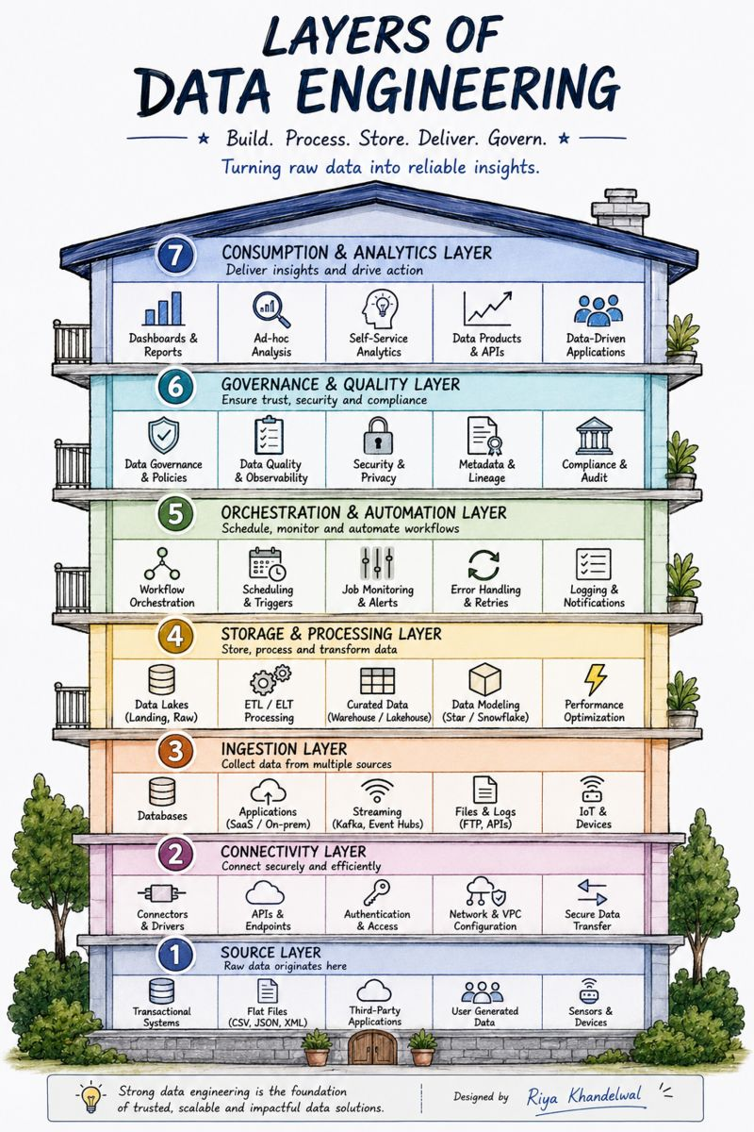

You can learn data analytics for free.
But only if you stop jumping between random tutorials.
The fastest way to improve is to learn the right skill from the right creator, then apply it immediately.
Here is a YouTube learning stack worth bookmarking:
→ Data Analyst Foundations
Alex The Analyst
Luke Barousse
CareerFoundry
365 Data Science
→ Excel, SQL & Spreadsheets
Leila Gharani
Chandoo
ExcelIsFun
TechTFQ
→ Python, Pandas & Statistics
codebasics
StatQuest
Data with Baraa
Keith Galli
→ Power BI, Tableau & Dashboards
Guy in a Cube
SQLBI
Tableau Tim
Pragmatic Works
→ Projects, Portfolio & Career
Ken Jee
Tina Huang
Mo Chen
Maven Analytics
The mistake is trying to watch everything.
Pick one area.
Choose one or two channels.
Follow a focused playlist.
Build a small project.
Explain what you learned.
Then move to the next skill.
That simple loop will teach you more than collecting 100 saved videos you never finish.
A strong data analyst is built through repetition across SQL, Excel, Python, statistics, dashboards, and real projects.
You do not need another expensive course to get started. You need a clear learning path, consistent practice, and proof that you can solve real problems.
YouTube can give you the knowledge. Your portfolio proves you can use it.
Which channel would you add to this list?
Activate to view larger image,



𝗧𝗵𝗲 𝗖𝗼𝗺𝗽𝗹𝗲𝘁𝗲 𝗗𝗮𝘁𝗮 𝗘𝗻𝗴𝗶𝗻𝗲𝗲𝗿𝗶𝗻𝗴 𝗥𝗼𝗮𝗱𝗺𝗮𝗽 (𝟭𝟬𝟬% 𝗙𝗿𝗲𝗲) 🛠️
SQL is where every Data Engineering journey begins and this roadmap takes you from total beginner to job ready, step by step, using only free resources.
Save this and follow it in order 👇
1. Learn SQL - Alex The Analyst, FreeCodeCamp, Ankit Bansal + practice on HackerRank & LeetCode. Master joins, window functions, and CTEs before moving on.
2. Python for Data Work - Corey Schafer, Tech With Tim + Google Colab & Kaggle. Focus on Pandas, file handling, and writing clean functions.
3. Understand Databases - PostgreSQL, MySQL, MongoDB. Learn the difference between relational and NoSQL, and when to use each.
4. Linux, Git & Command Line - NetworkChuck, TechWorld with Nana. Get comfortable with bash scripting, SSH, and version control basics.
5. Data Warehousing - BigQuery, Snowflake, Redshift. Understand OLAP vs OLTP and columnar storage.
6. Data Modeling - Kimball dimensional modeling: facts, dimensions, star vs snowflake schemas.
7. ETL & ELT Pipelines - DataTalksClub Zoomcamp (GOLD! 🏆). Build your first end-to-end pipeline here.
8. Docker Basics - Run Postgres, Airflow & Spark locally. Learn images, containers, and docker-compose.
9. Workflow Orchestration - Airflow, Prefect, Dagster, Kestra. Understand DAGs, scheduling, and retries.
10. dbt for Transformations - Learn models, tests, snapshots, and documentation-as-code.
11. Big Data with Spark - Databricks Community Edition. Get familiar with distributed computing and PySpark.
12. Streaming with Kafka - Build a producer-consumer project; learn topics, partitions, and consumer groups.
13. Cloud Data Engineering - AWS, GCP, Azure. Pick one cloud and go deep (IAM, storage, compute basics).
14. Data Lakes & Lakehouses - Parquet + DuckDB. Explore Delta Lake or Iceberg for lakehouse concepts.
15. Data Quality & Testing - Great Expectations, Soda. Learn to validate schemas and catch bad data early.
16. CI/CD for Data Pipelines - GitHub Actions basics for automated testing and deployment.
17. Monitoring & Observability - Learn logging, alerting, and pipeline health checks.
18. Build Real Projects 🚀 - 2/3 end-to-end pipelines (ingestion → transformation → warehouse → dashboard) for your portfolio.
🧑‍💻𝗥𝗲𝗮𝗱 𝗧𝗵𝗶𝘀 𝗗𝗮𝘁𝗮 𝗘𝗻𝗴𝗶𝗻𝗲𝗲𝗿𝗶𝗻𝗴 𝗚𝘂𝗶𝗱𝗲 👇
Learn Data Engineering End-to-End 🚀
🔹The Complete Data Engineering Roadmap for 2026: https://lnkd.in/eM5JHuyg
🔹 FREE AWS, AZURE & GCP DATA ENGINEERING ROADMAP : https://lnkd.in/e4G8MxdR
Save and Share If you find this useful !!
Follow Abhisek Sahu for more regular Data , Cloud , Career Insights
hashtag#dataengineering hashtag#dataengineer hashtag#freeresources



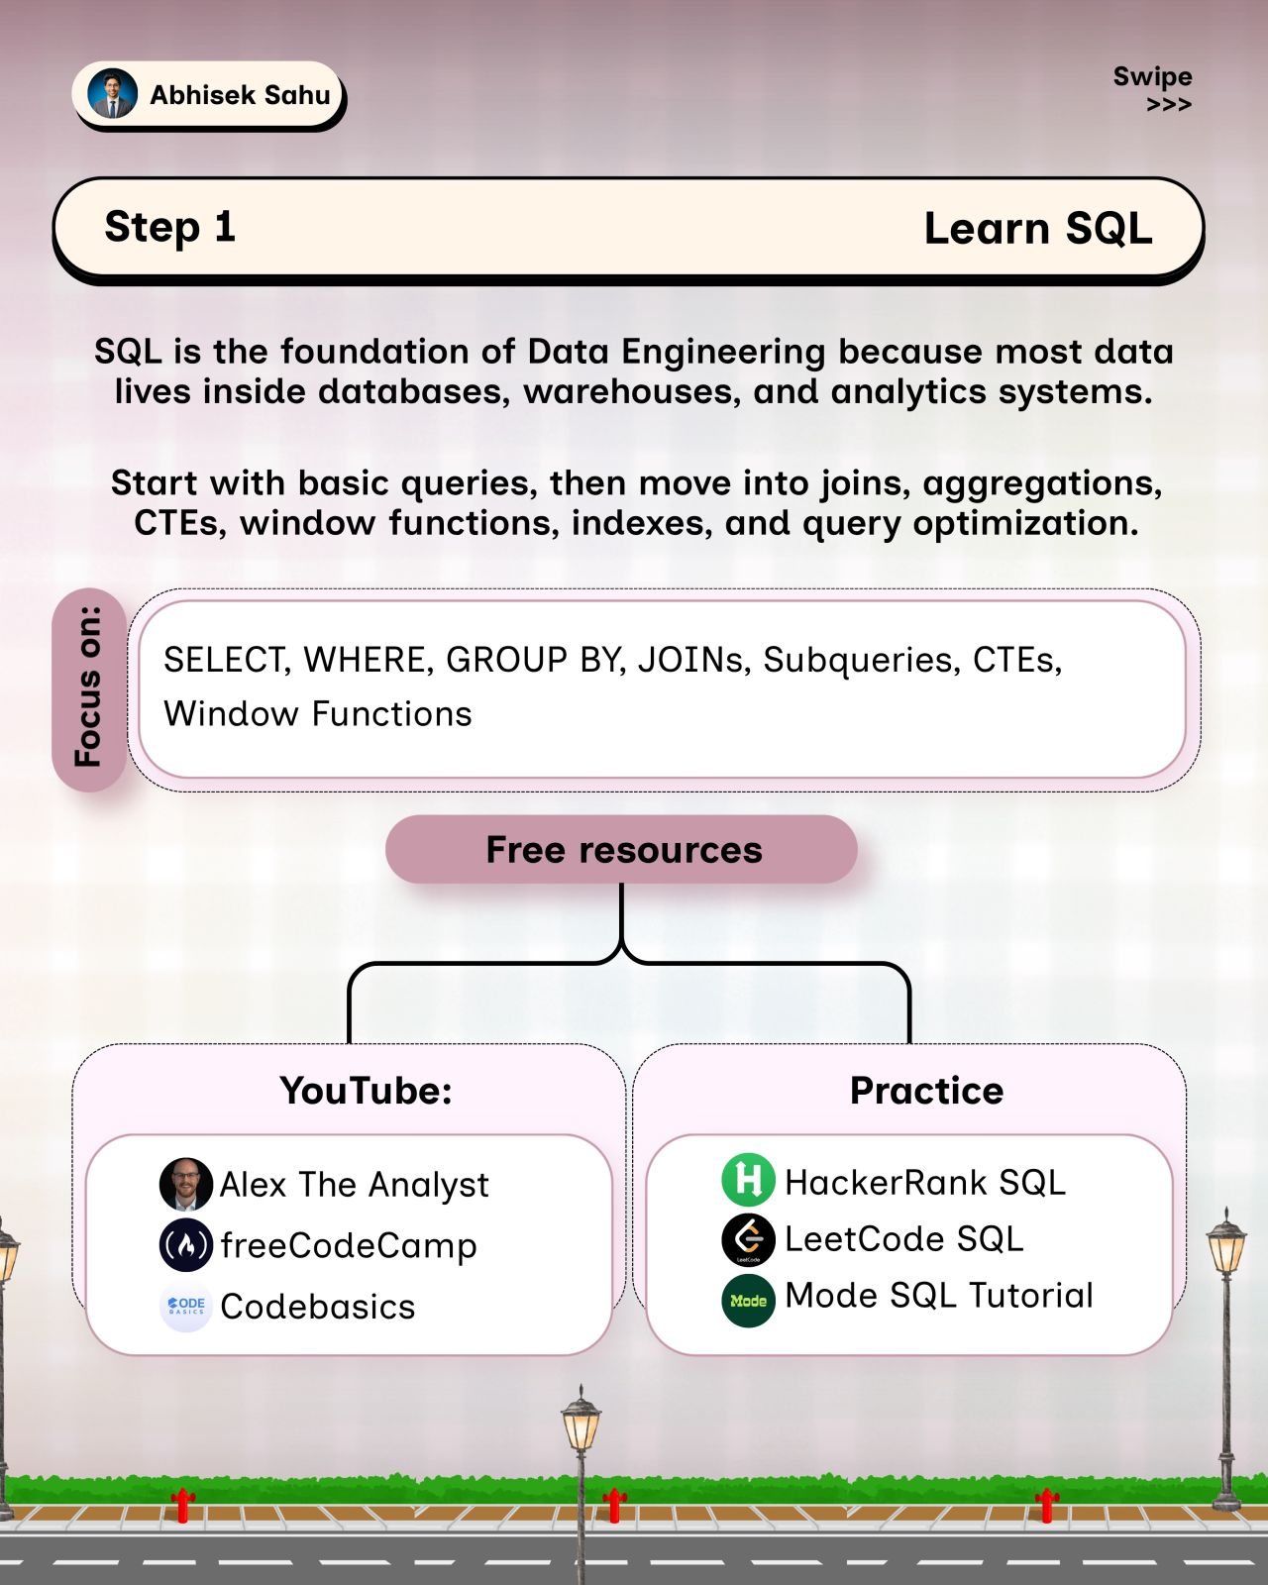

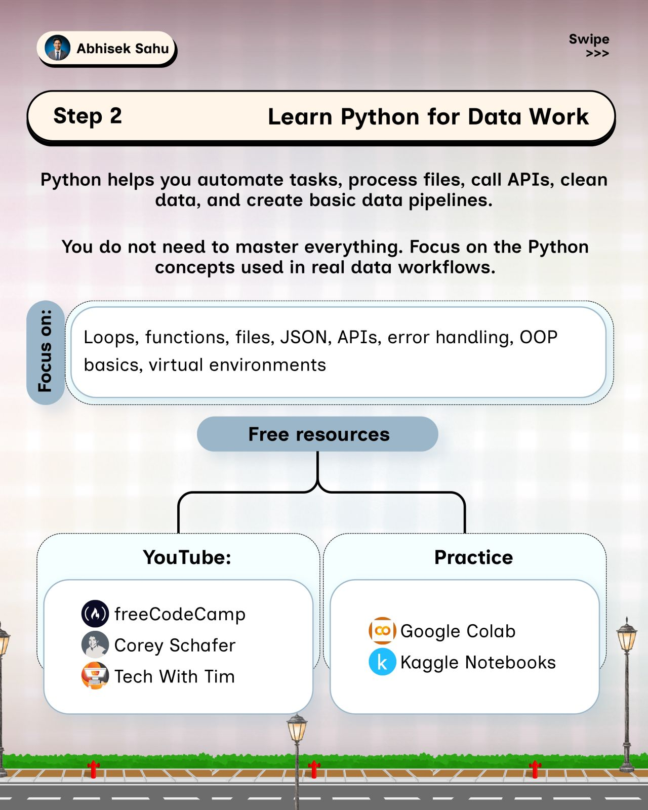

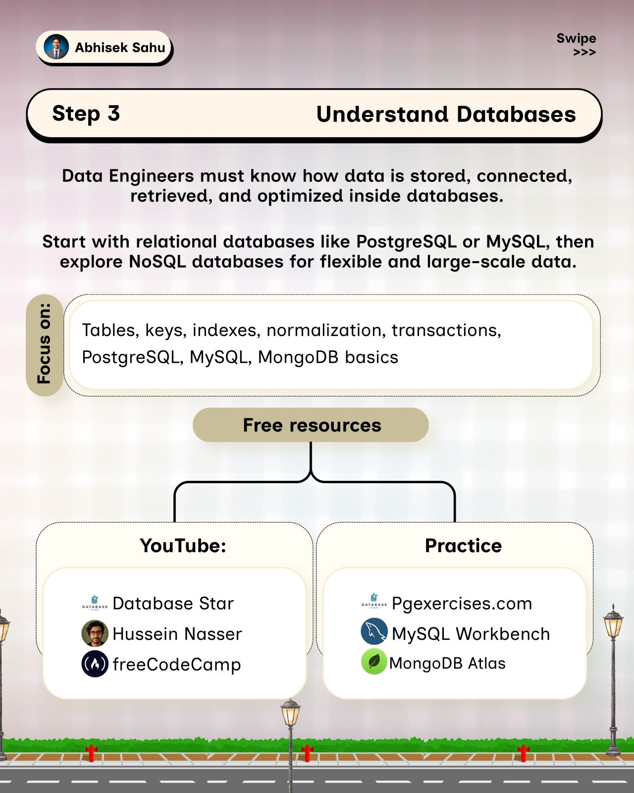

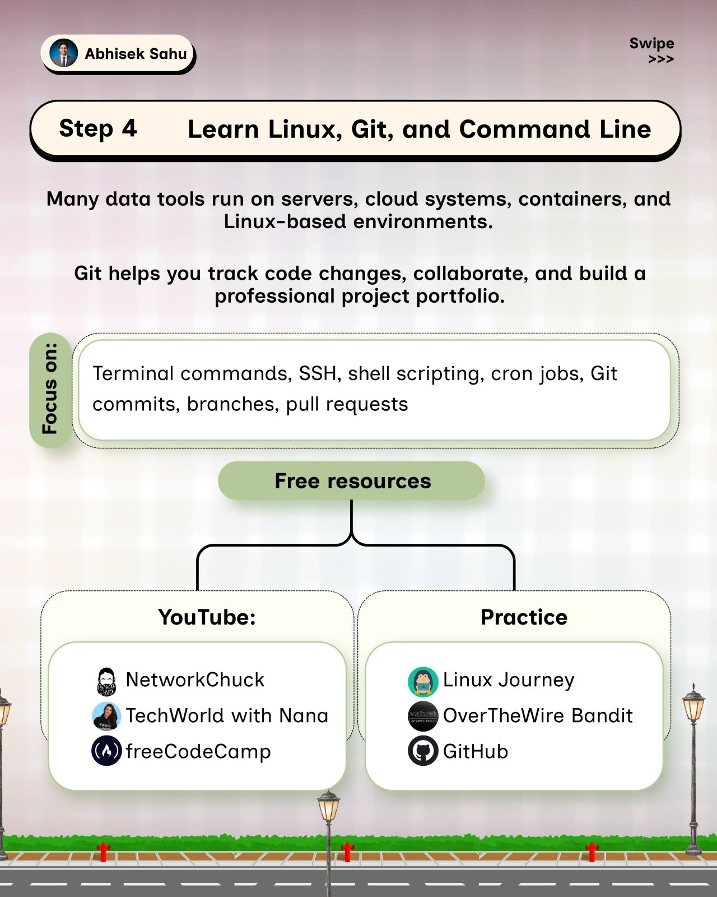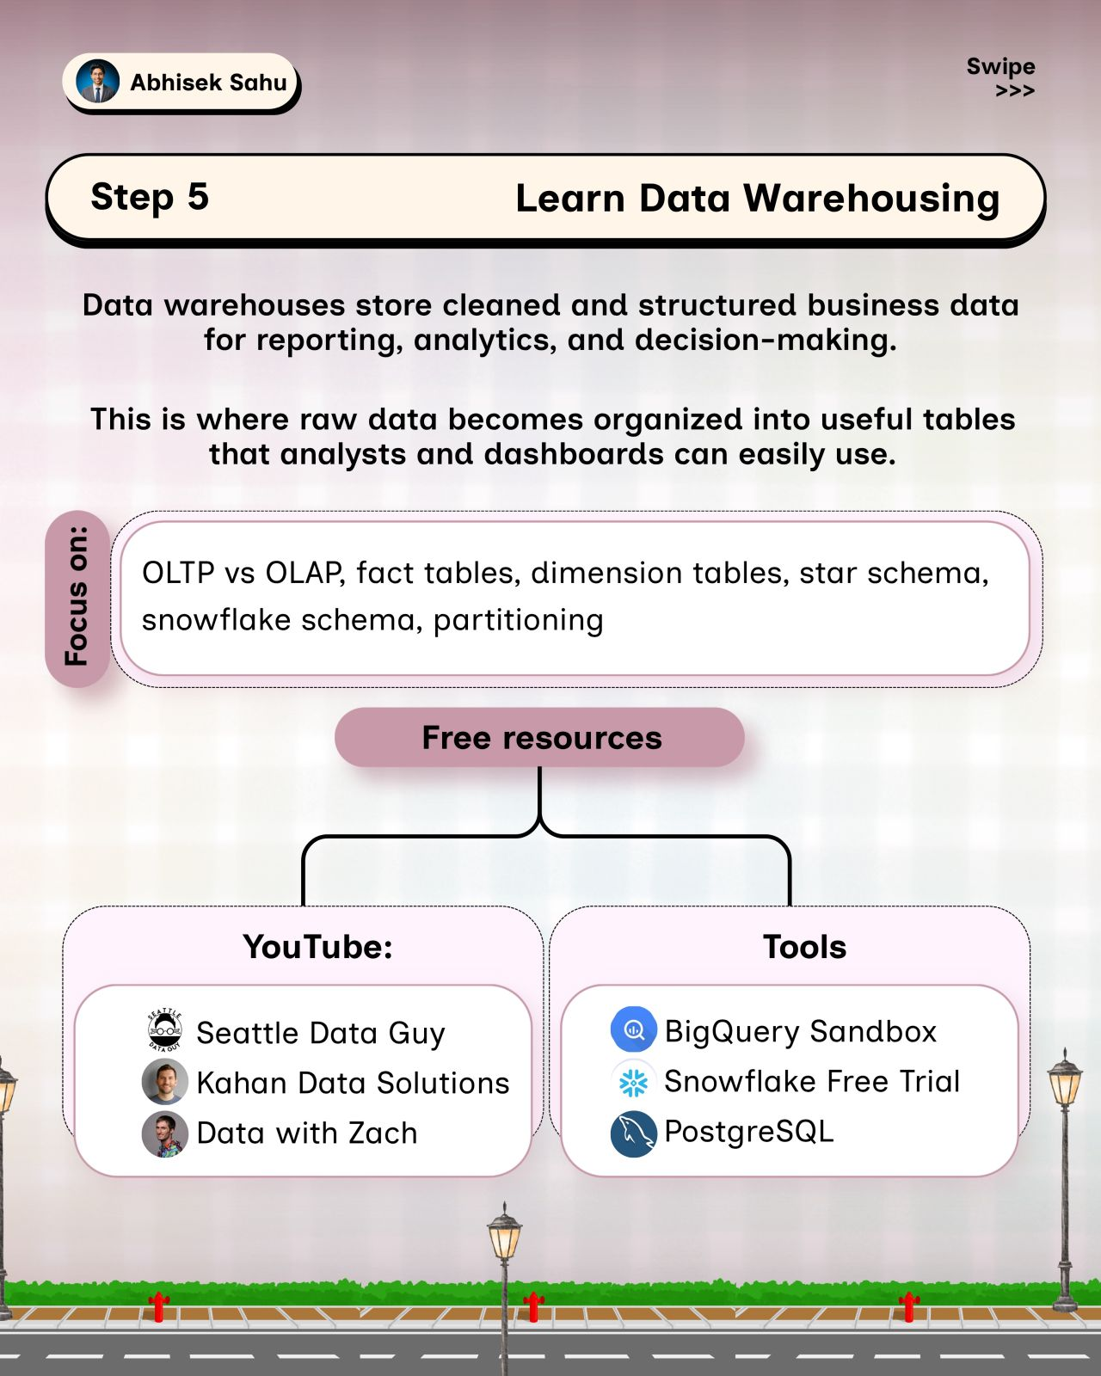

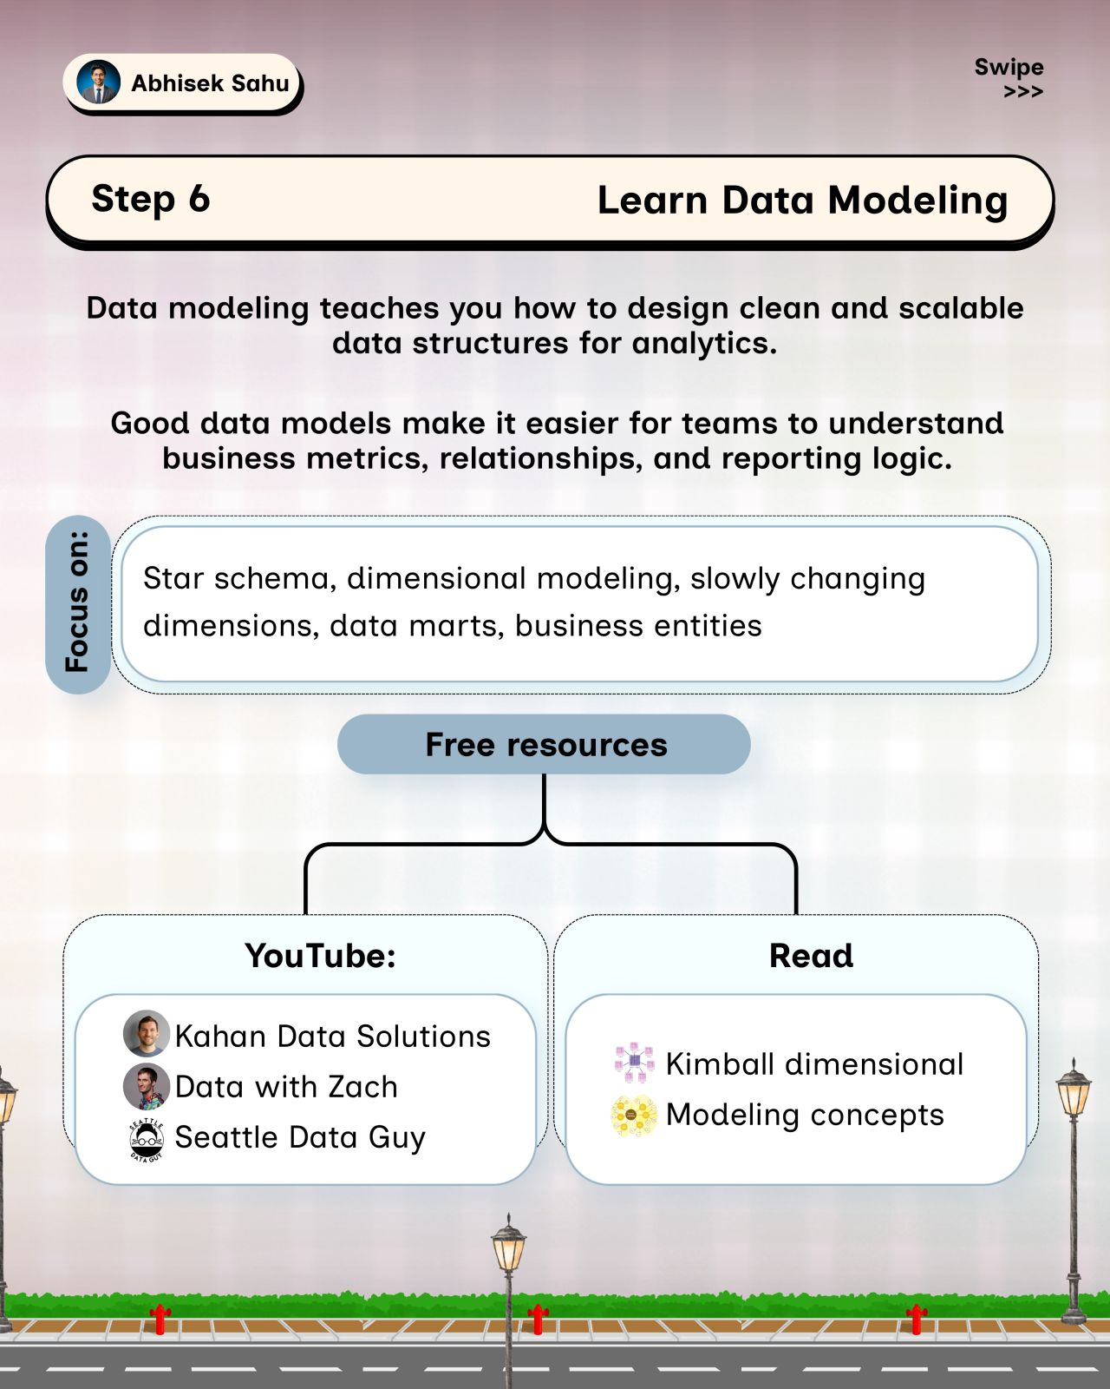

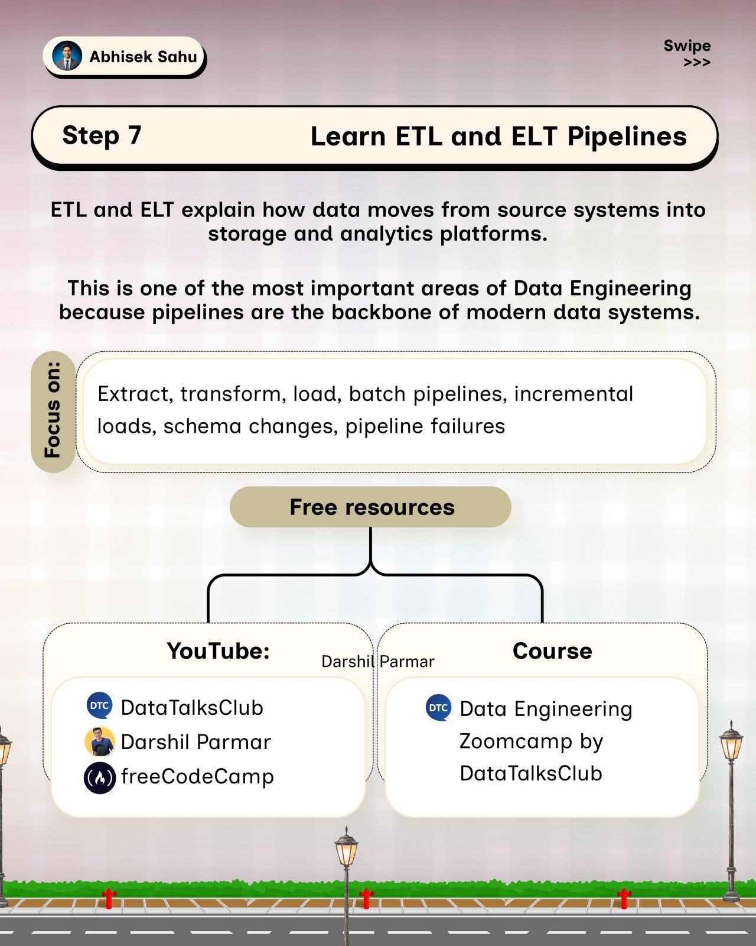

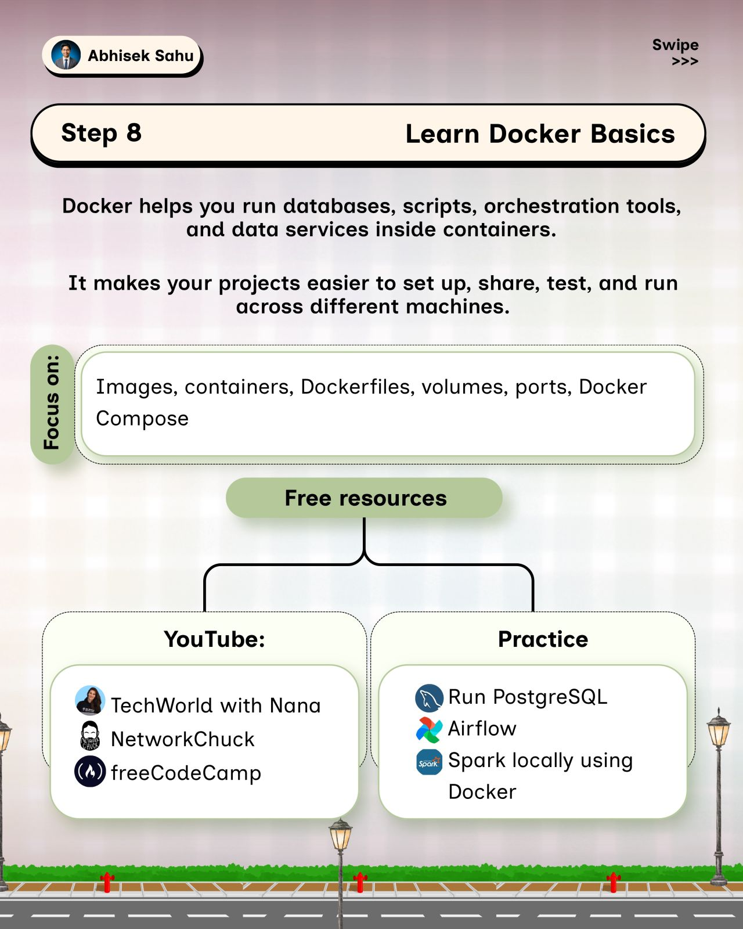

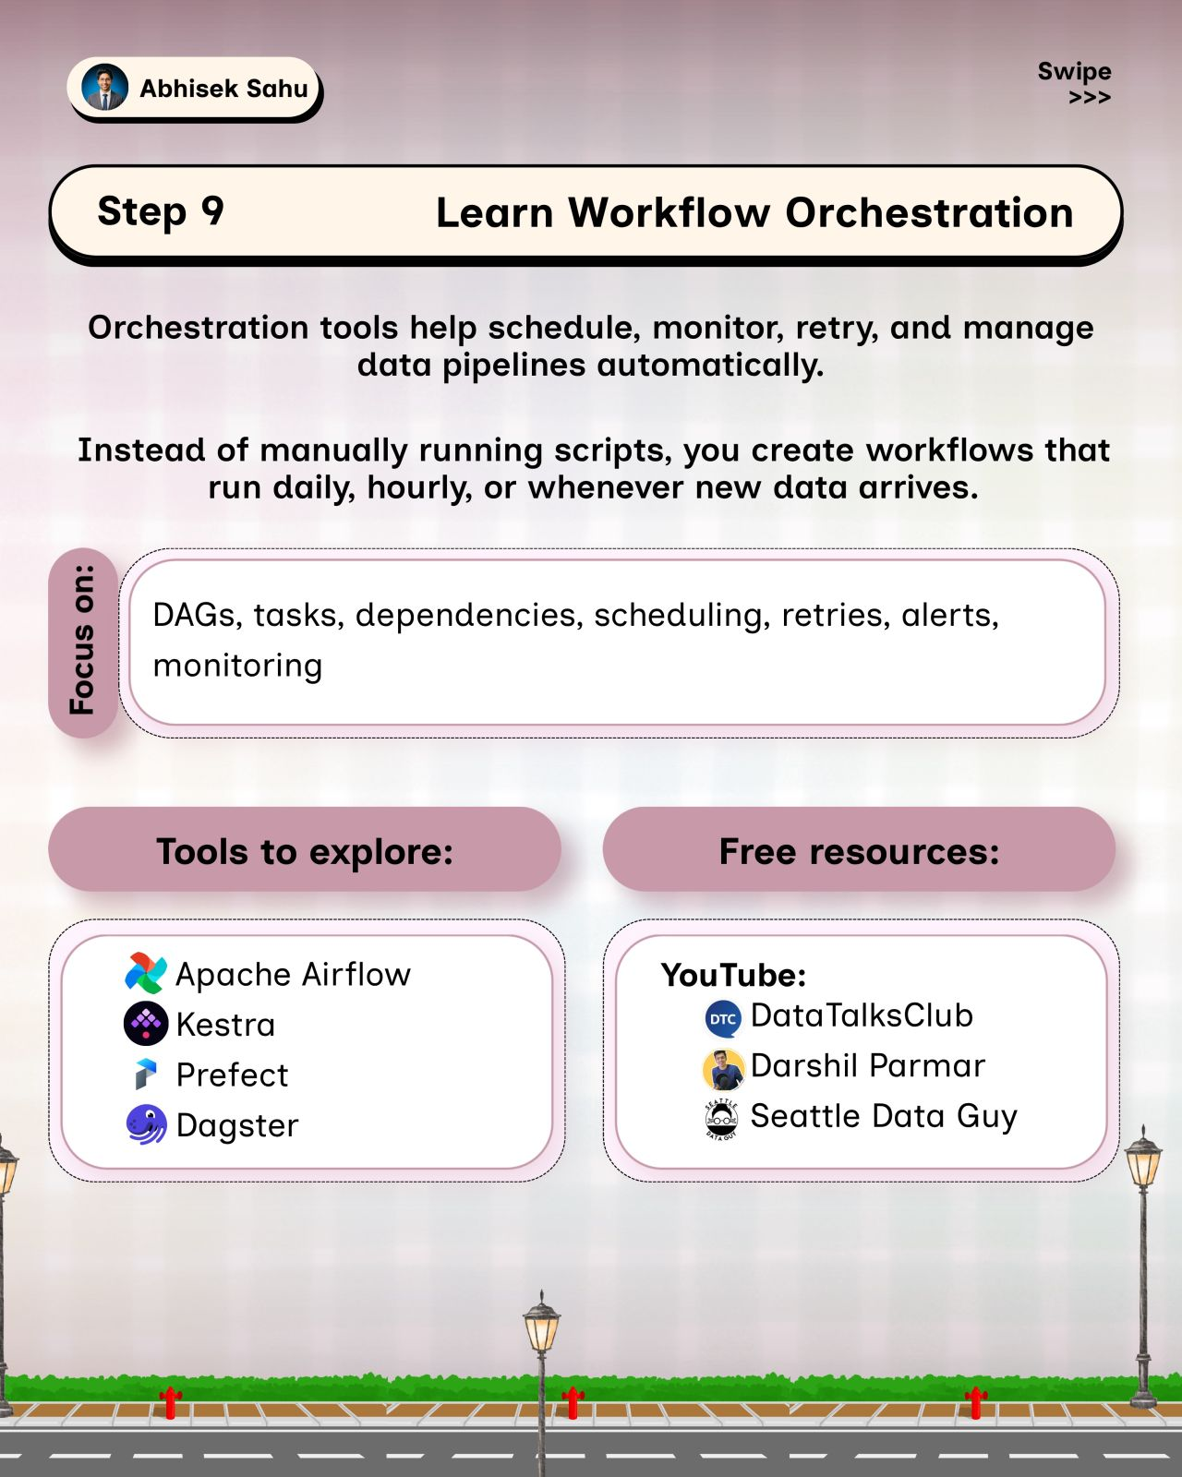

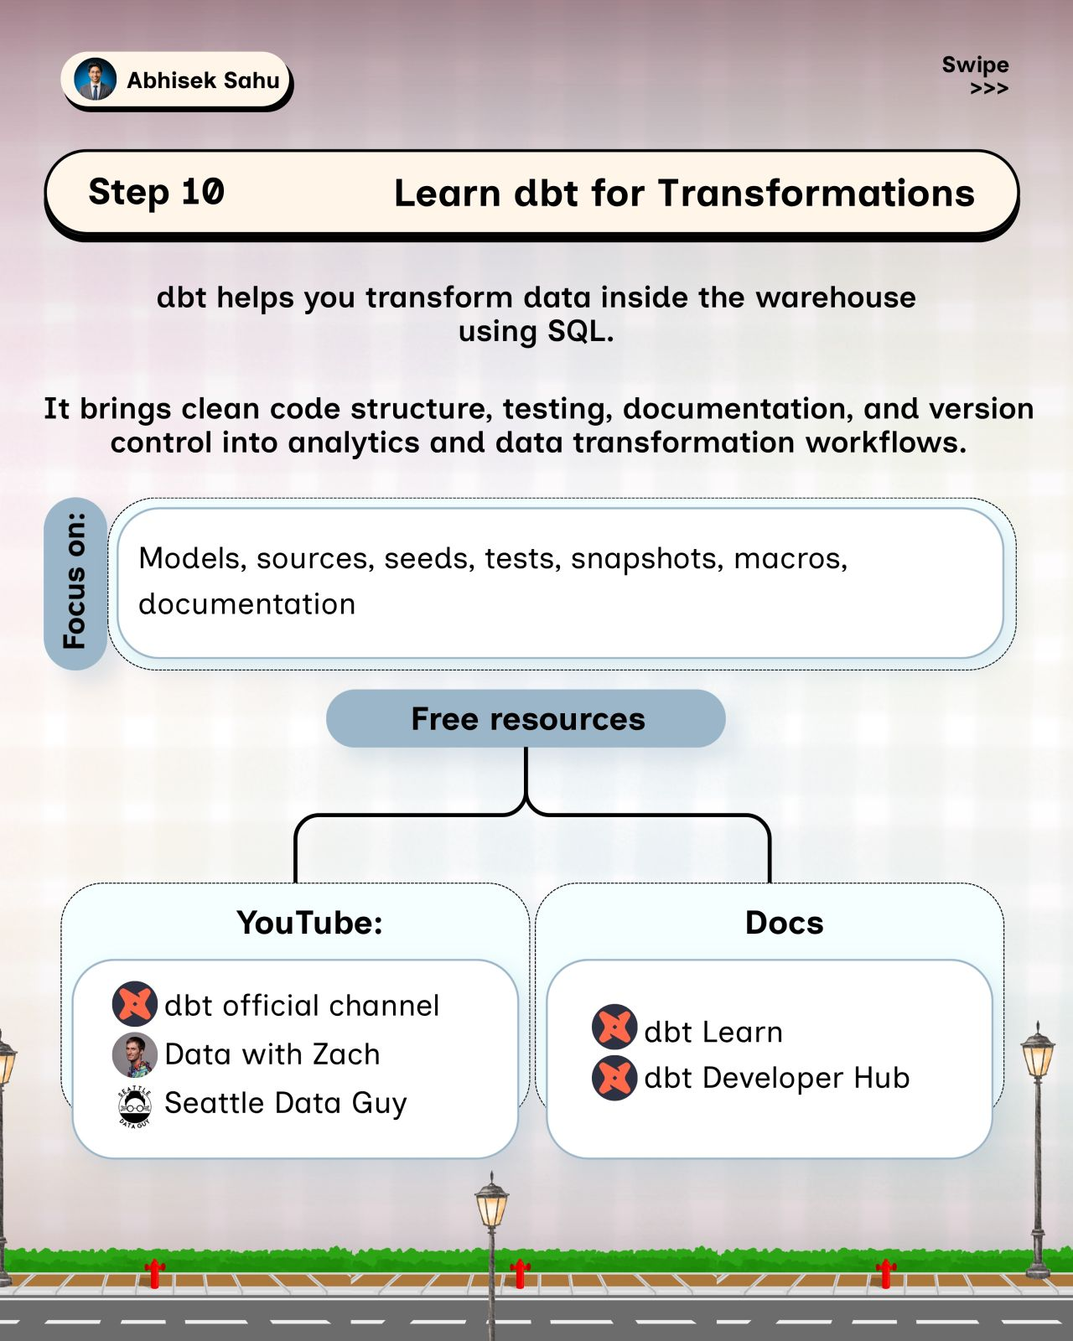

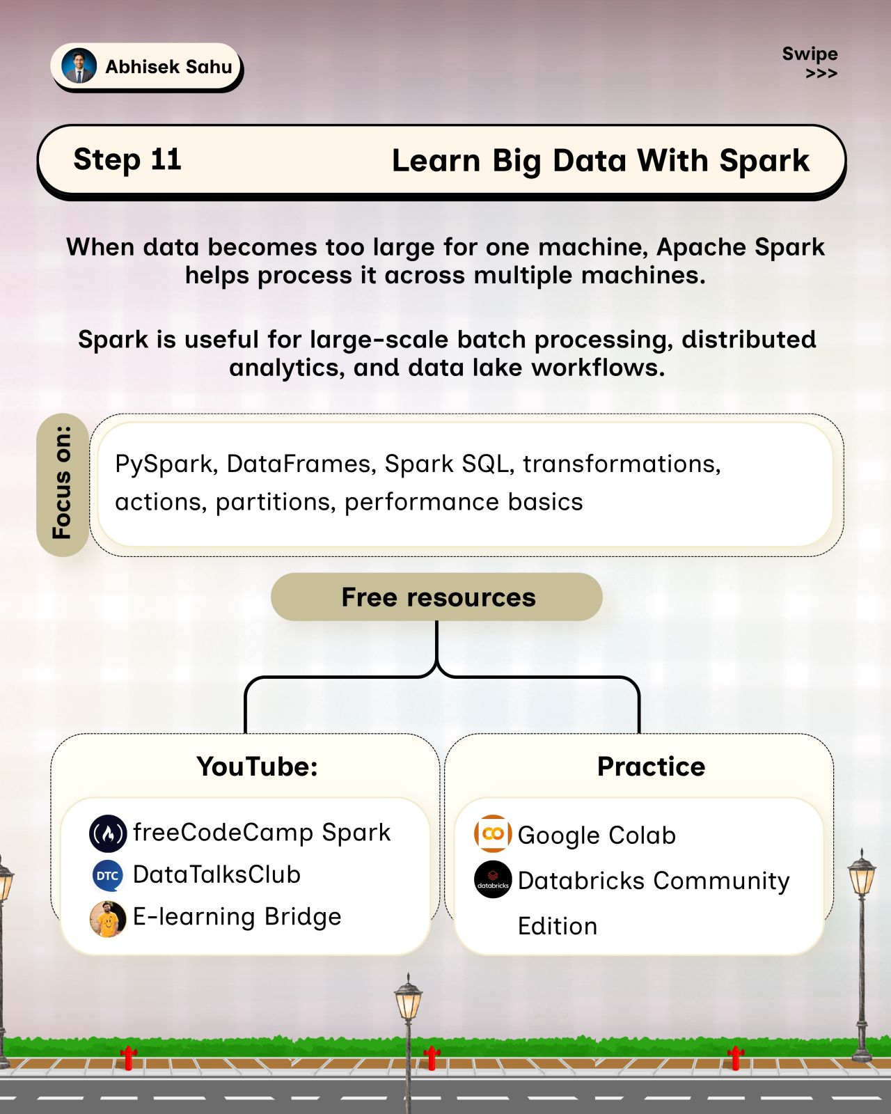

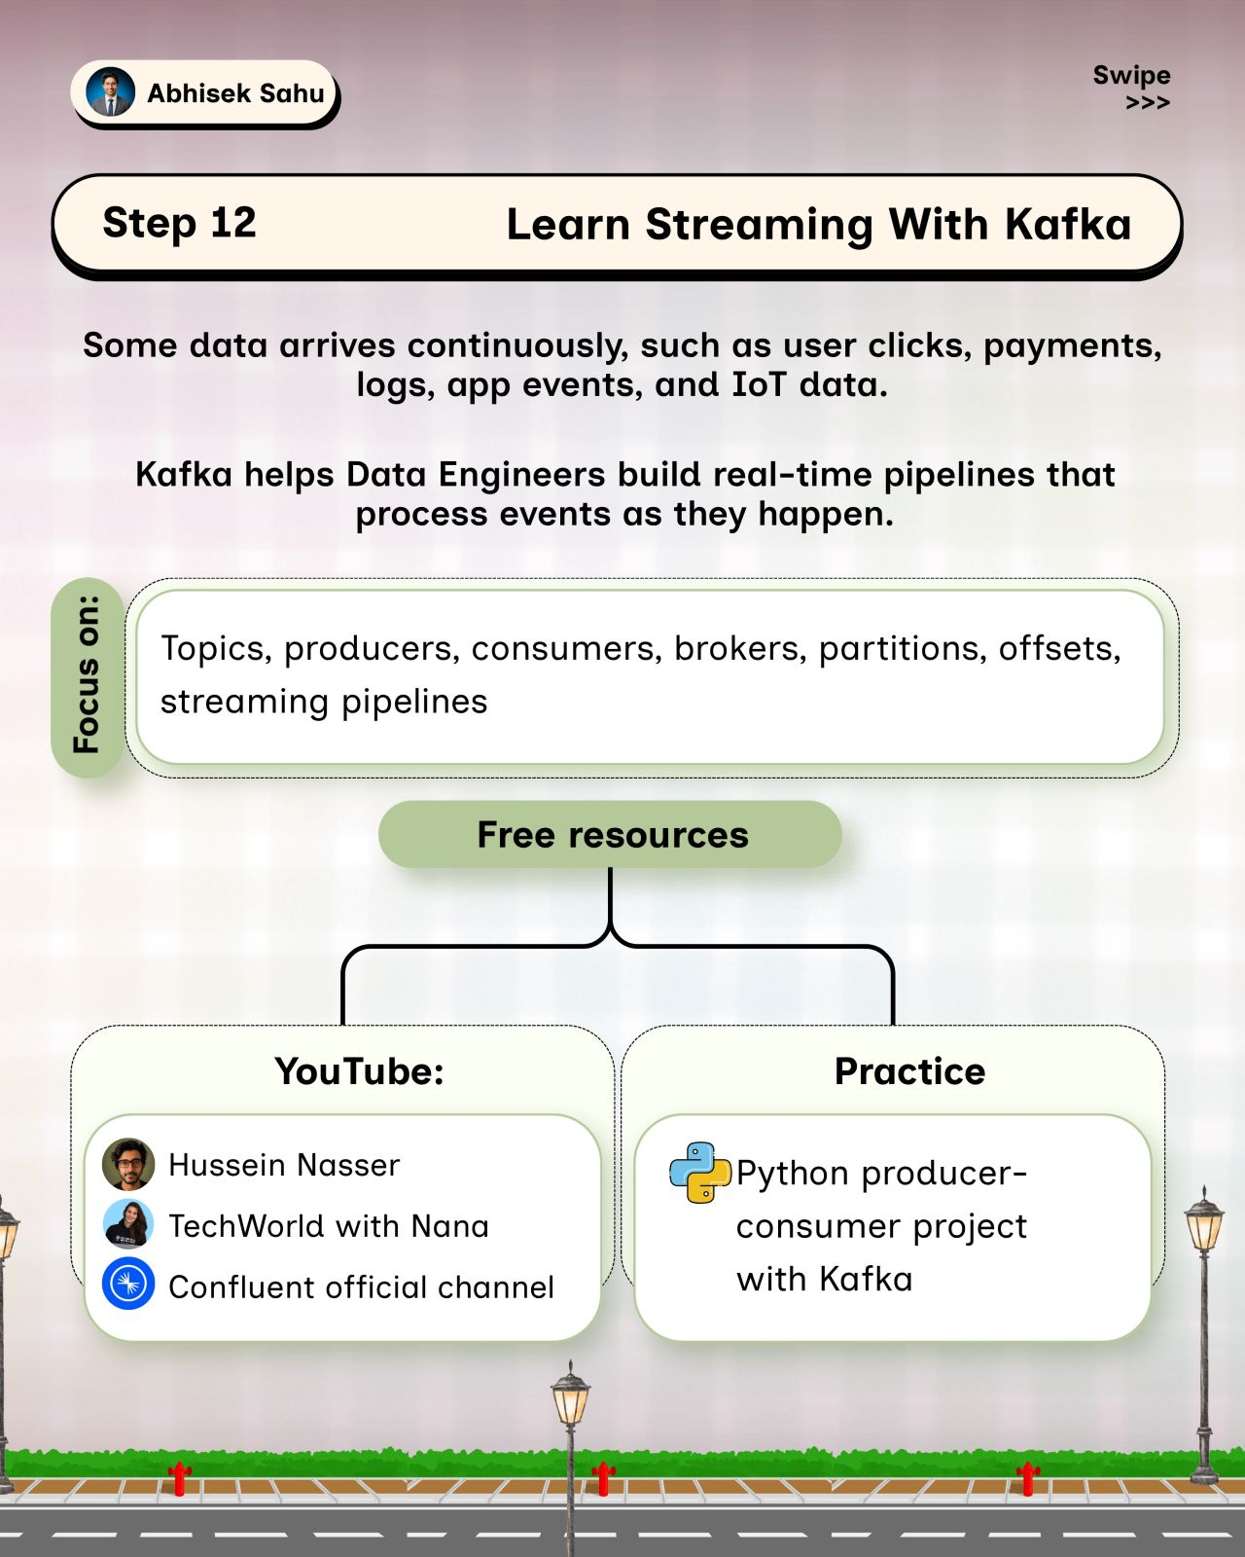

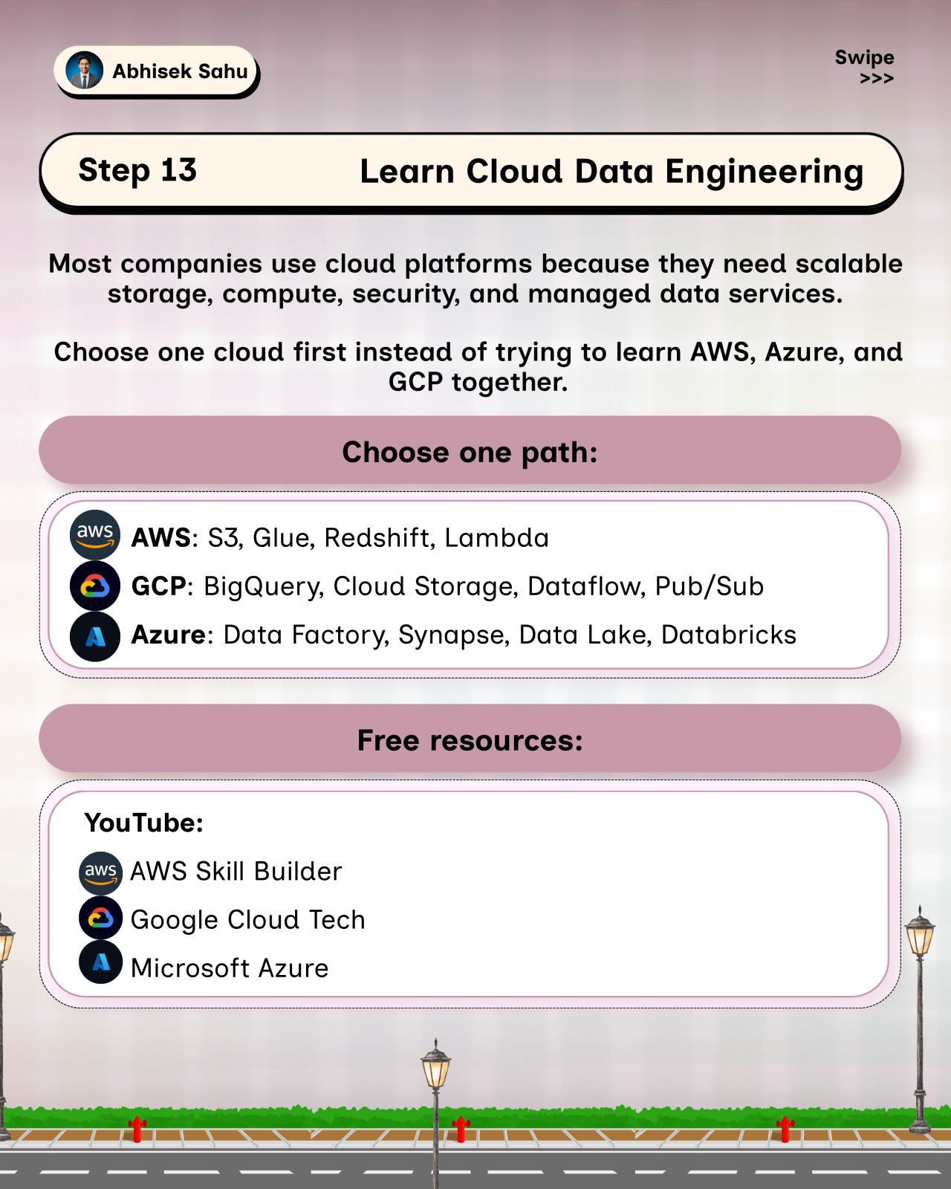

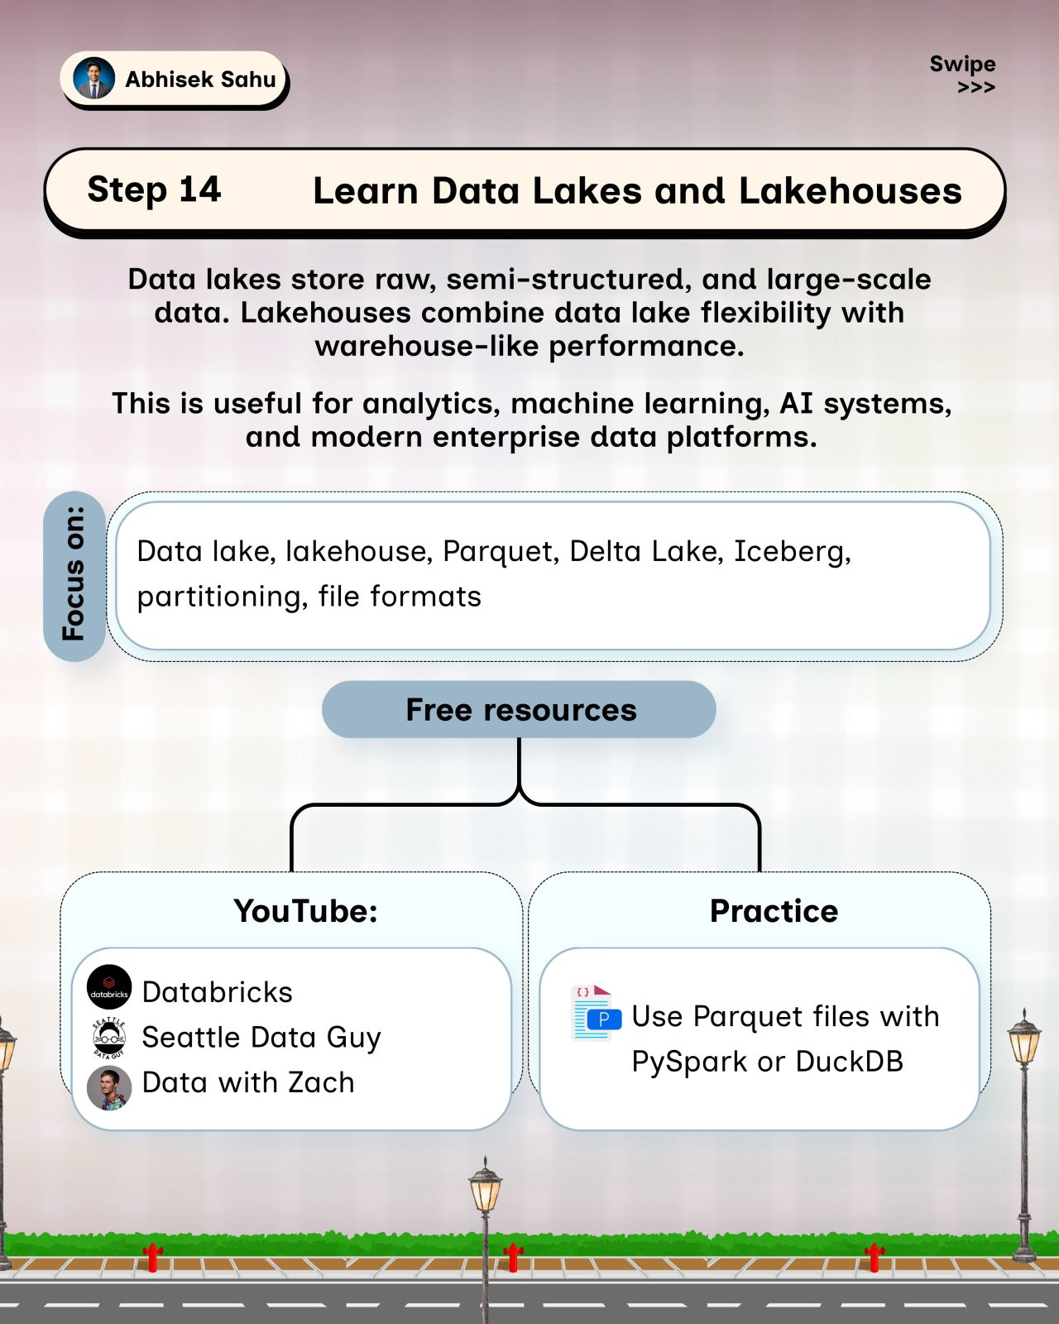

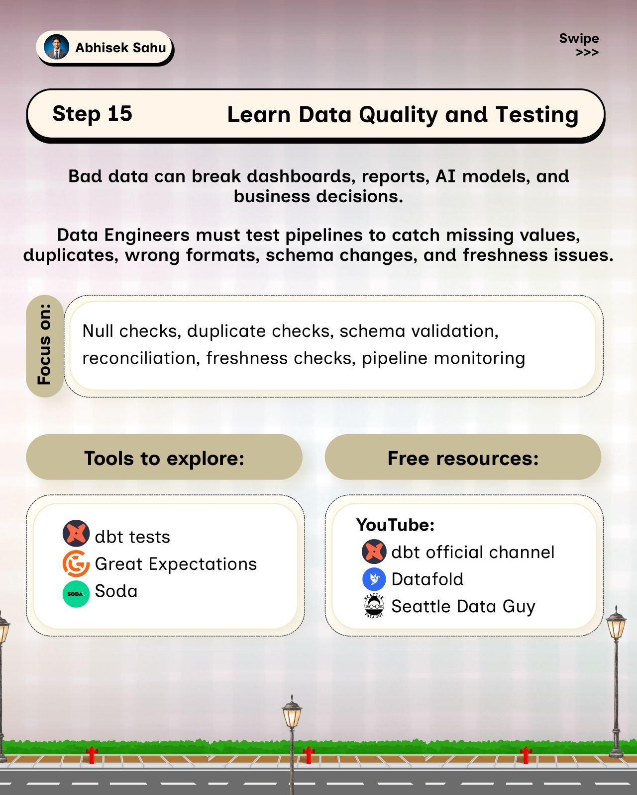

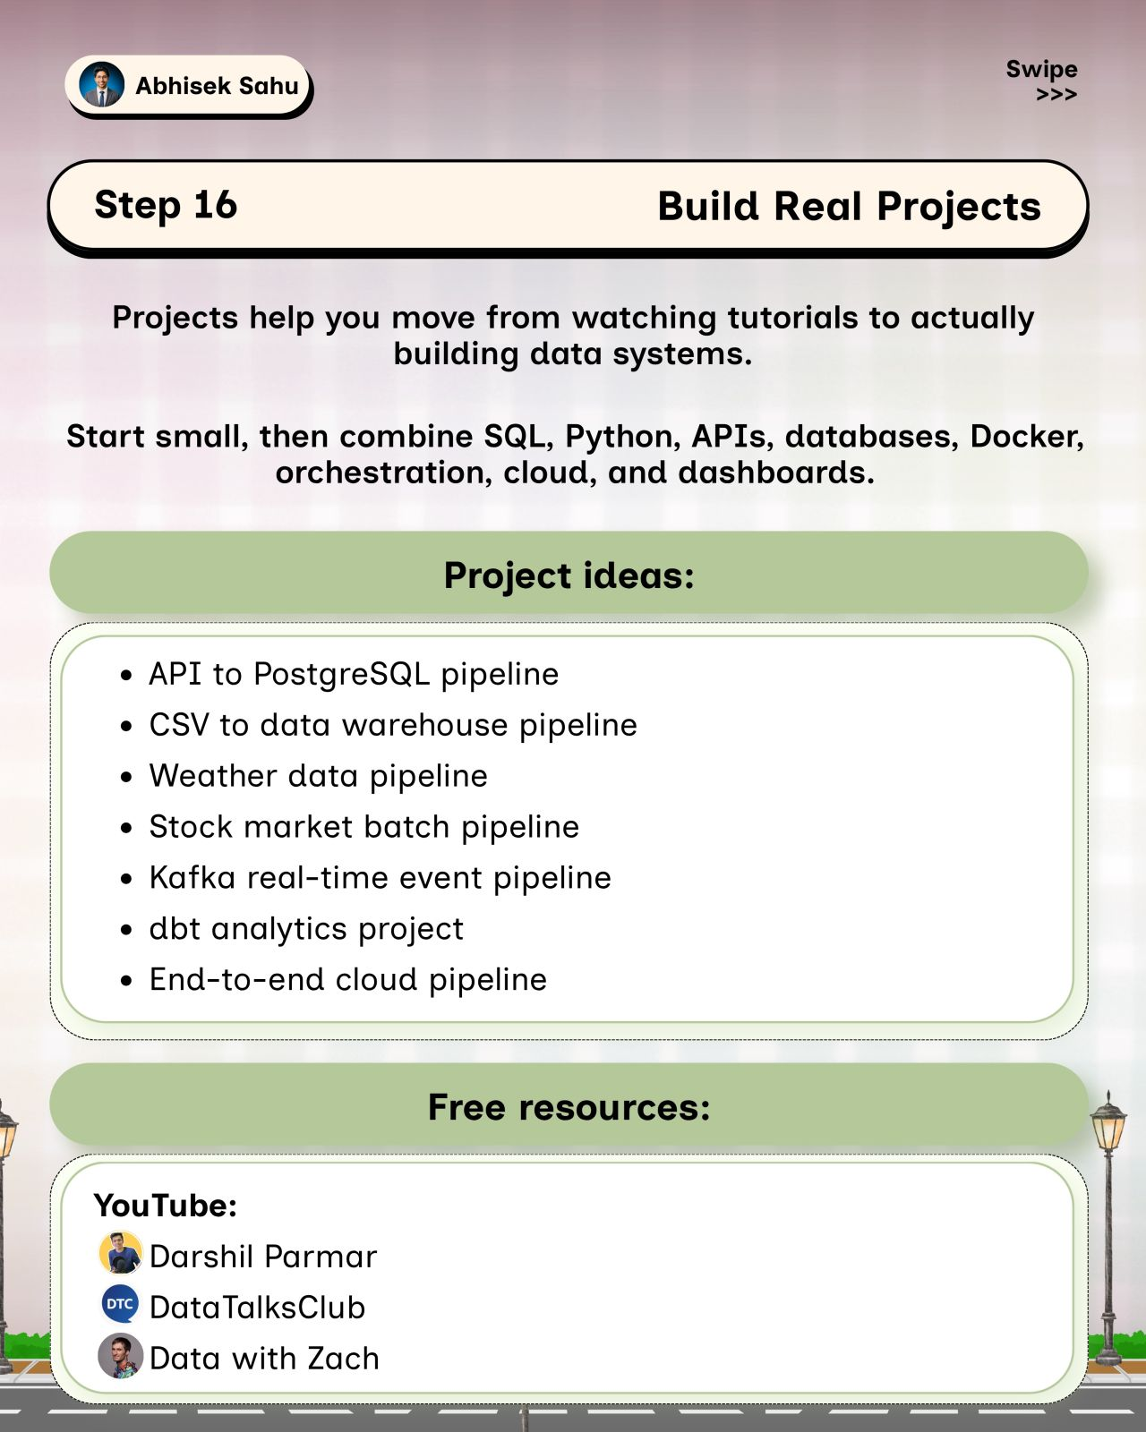

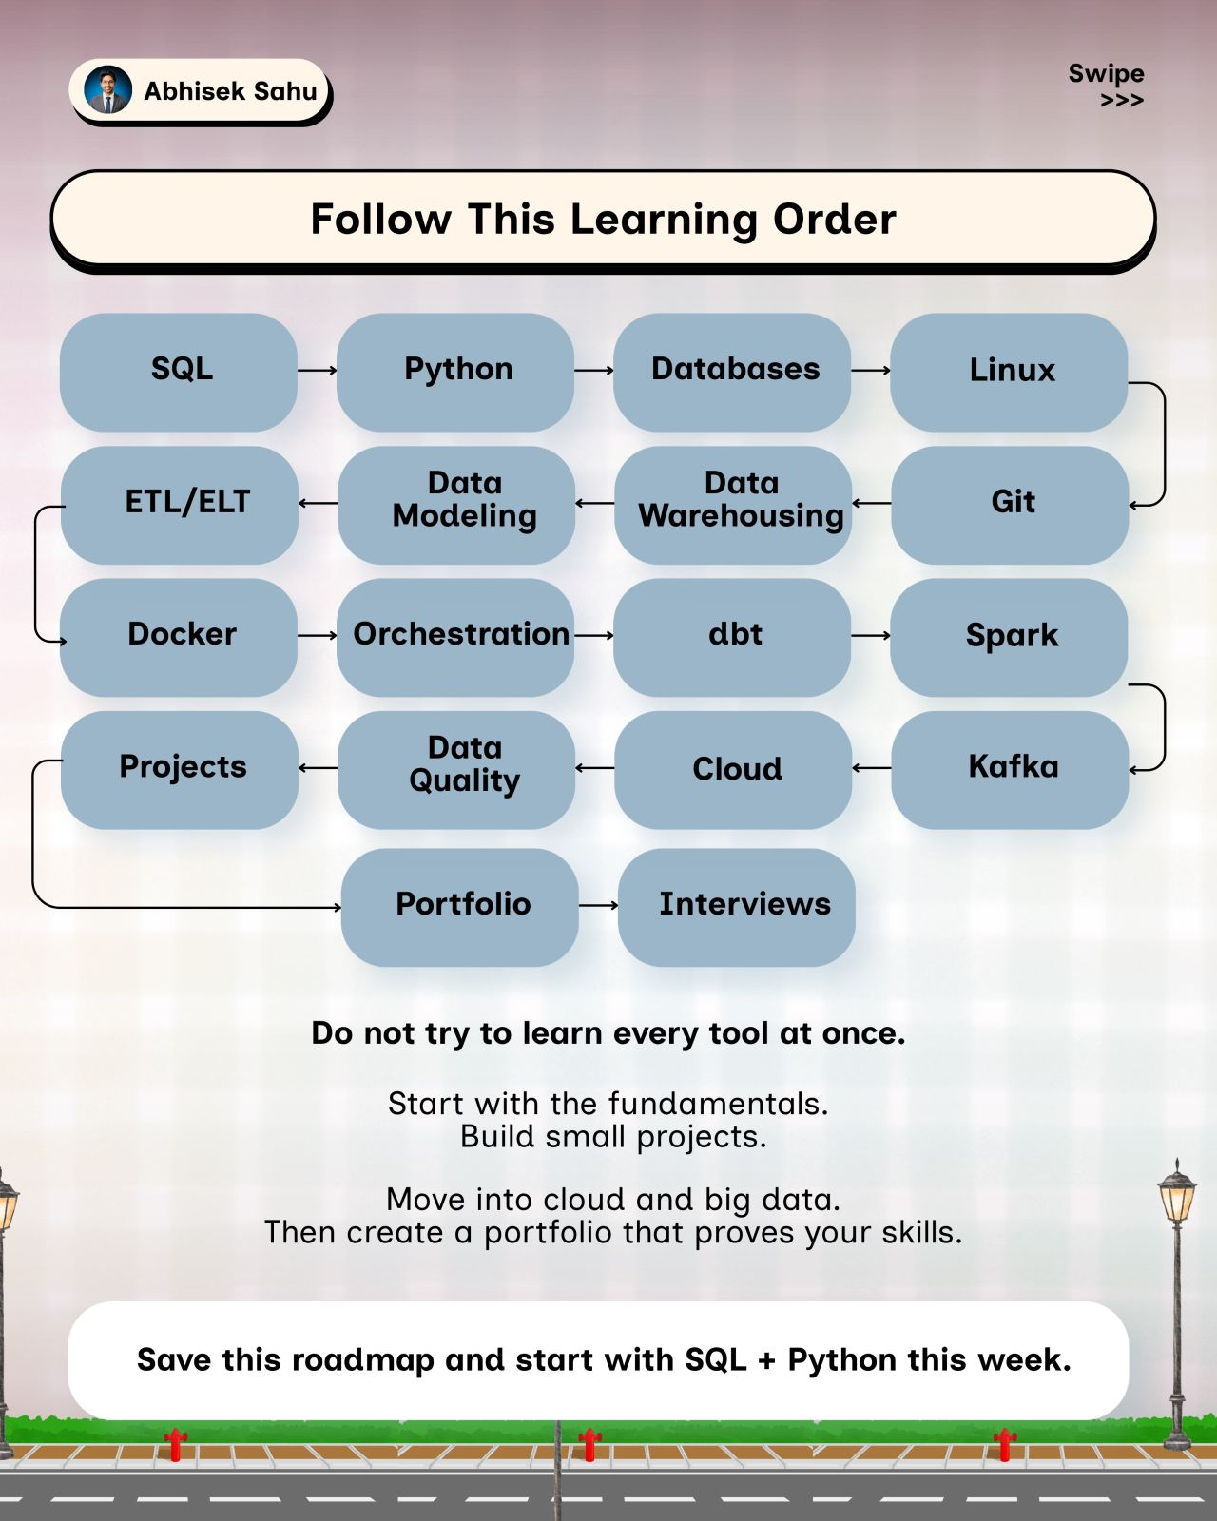

𝗟𝗲𝗮𝗿𝗻 𝗙𝗶𝗹𝗲 𝗙𝗼𝗿𝗺𝗮𝘁𝘀 𝗶𝗻 𝟵𝟬 𝗦𝗲𝗰𝗼𝗻𝗱𝘀 📦
A Data Engineer works with files every single day.
But choosing a file format shouldn't be a habit.
It should be an architectural decision.
If I asked you:
❓ When would you choose CSV over Parquet?
❓ Why is Parquet better suited for analytical workloads?
❓ What makes Avro useful for streaming and schema-driven pipelines?
❓ What is the difference between a file format and a table format?
❓ Why do Delta and Iceberg build capabilities on top of columnar storage?
❓ When should you use ORC instead of Parquet?
These decisions can have a direct impact on performance, storage, interoperability, schema evolution, and scalability.
So I created this 90-second cheat sheet to make the differences easier to understand.
📖 Here's what you'll learn:
✅ What a file format actually defines
✅ Row-based vs columnar storage
✅ CSV vs JSON vs Avro
✅ Parquet vs ORC
✅ Delta vs Iceberg
✅ When each format makes sense
✅ How to choose a format based on the workload
✅ Where these formats fit in modern data platforms
💡 One concept every Data Engineer should remember:
𝗦𝗮𝗺𝗲 𝗗𝗮𝘁𝗮. 𝗗𝗶𝗳𝗳𝗲𝗿𝗲𝗻𝘁 𝗙𝗼𝗿𝗺𝗮𝘁. 𝗗𝗶𝗳𝗳𝗲𝗿𝗲𝗻𝘁 𝗜𝗺𝗽𝗮𝗰𝘁.
📄 CSV / JSON → Simple exchange & semi-structured data
⚡ Avro → Schema-driven, row-based pipelines & streaming
📊 Parquet / ORC → Columnar analytics at scale
🏗️ Delta / Iceberg → Table-level capabilities for modern lakehouse architectures
The important part isn't memorizing the formats.
It's understanding why you would choose one over another.
Once you understand that distinction, concepts like column pruning, compression, schema evolution, partitioning, ACID transactions, and lakehouse architecture start making much more sense.
📌 Save this for your next Data Engineering project or interview.
📌𝗟𝗮𝘀𝘁 𝗱𝗮𝘆 𝗹𝗲𝗳𝘁!
𝗗𝗼𝗻'𝘁 𝗺𝗶𝘀𝘀 𝘆𝗼𝘂𝗿 𝗰𝗵𝗮𝗻𝗰𝗲 𝘁𝗼 𝗷𝗼𝗶𝗻 𝗼𝘂𝗿 𝟰𝘁𝗵 𝗗𝗮𝘁𝗮 𝗘𝗻𝗴𝗶𝗻𝗲𝗲𝗿𝗶𝗻𝗴 𝗖𝗼𝗵𝗼𝗿𝘁 𝗮𝗻𝗱 𝗯𝘂𝗶𝗹𝗱 𝘁𝗵𝗲 𝘀𝗸𝗶𝗹𝗹𝘀 𝗻𝗲𝗲𝗱𝗲𝗱 𝘁𝗼 𝗹𝗮𝘂𝗻𝗰𝗵 𝘆𝗼𝘂𝗿 𝗗𝗮𝘁𝗮 𝗘𝗻𝗴𝗶𝗻𝗲𝗲𝗿𝗶𝗻𝗴 𝗰𝗮𝗿𝗲𝗲𝗿. - https://lnkd.in/gPiDZuyS
Activate to view larger image,
